Students Name:
Course:
Subject:
Date:

Research Paper on Great Depression.

Abstract
Long ago between 1929 to 1939, the great economic down turn prevailed. Majorly, it had been caused by some of the factors such as stock market crush in 1929, strict policies on European trade passed by federal government to limit imported goods and improve domestic trade. The stock market crush brought about low consumption habits hence steering down the economy. Similarly ,9000 domestic banks failed as a result hence contributing in economic downturn. Finally, Dust Fowl is an overlooked cause of economic depression.
Generally, the great economic depression caused a lot of un employment, low consumption and investment rate. Reasonably, the liberal economic doctrine thought of controlling the crisis through curtailing government budget expenditures and natural forces. Unfortunately, the rapid demographic changes could not allow such measures to control the crisis. Alternatively, state intervention and application of economic policies was essential to control the tide. classical policies were not adequate enough to streamline the economy, instead they could lower or disrupt more on the crisis.

Key Words
Federal Reserves, Economic Depression, Monetary Policy, Federal Policy, Money Base, Bank Deposits, Discount Rates, Stock Market Crush, Dust Fowls, Liquidity Trap, Recession.

Empirically, various economists tried to analyze the cause and the measure taken to curb the great depression. Different views were put across. Basically, we intent to reveal the effectiveness of monetary policy in curbing the great depression as discussed by various early economists such as Friedman, Schwartz, Krugman and Keynesian.
As they interpreted the cause of the depression, they too looked at the distinct variation between monetary base, that is the summation of the currency and bank reserves against the money supply. money supply comprises of summation of currency and bank deposits. The federal controls the money base directly thus application of fiscal federation and monetary policy. As result of bank failure in the early years of the depression, the monetary base rose up diverging from money supply which fell sharply. Alternatively, investors and consumers decided to hold their cash in hand after losing trust with the banks while the banks reduced lending out and started holding a lot of cash in hand to avoid the risk of bank run since some banks had run short of funds and exited the financial industry as a result. Generally, there was less investing, lending and consumption as a result of holding much cash. This habit steered the depression.
Argumentatively, Keynes claims that monetary policy could be less effective in some case such as in depression. When money supply increases, tax rates should be lowered to attract more borrowing thus increase in investment hence rise in output. In case interest rates does not fall like it appears in a liquidity trap, then change in money supply does not stimulate investment and therefore the monetary policy proves to be less effective in such a case. Arguing according to the economic depression, Keynes was fairly right to prove that monetary policy was less effective here.
Critically, Freedman and Schwartz stood to refute Keynes claim that monetary policy was ineffective. Instead, they claimed that in absence of liquidity trap, it could also be effective enough. John Krugman quoted an incidence in japan of similar case he observed. Freedman and Schwartz maintained that, a decline in money supply caused an ordinary depression which was controllable using monetary policy. Additionally, the federal reserve stimulated the ordinary recession to a great economic depression when it failed to control the situation by lending the banks more money at the time of falling which could have curbed the whole matter in advance instead.
In absence of federal reserve, we ended up in the great depression. Actually, if the federal reserve intervened and adjusted the discount rates, it could have controlled lending as well as investment rates thus altering general output and consumption as well. For instance, since both banks and consumers held a lot of cash in hands both, it would have been wise for the federal reserve to raise the bank deposits to lower lending rates, increase interest rates to attract savings and regulate the excess cash in supply.
Paul Krugman maintains that monetary policy was less helpful in 1930’s during the great depression. Applying expansionary monetary policy is likely to have worsened the situation. After the financial crisis and the lending rates dropped to almost zero, investors could have benefitted a lot but at liquidity level, since there’s no motivation for lending, there could be less lending. this incidence is said to have been observed in japan in the late 1990’s.
Accordingly, I would claim that in such a case, both federal regulation policies and fiscal policies could have resolved it better. For instance, if the central put it that all commercial banks should deposit with her say 60 % of the total deposits they had, then it would have controlled a lot of cash in hand likely to influence inflation. Similarly, tax rates should be raised in such a case to minimize frequent borrowing hence encouraging consumers to utilize the cash they held. In case more investments and outputs were required in the economy to curb the matter, then the opposite is wise and true to do. The tax rates should be lowered to attract more borrowers, raising both investment and out put rates in the given economy. Truly, monetary policy was less effective in this case.
Below is the graphical presentation of the great depression of before, in the course and after the depression.
The graph below shows the economic potential output during the period of depression against the current GDP in the meantime, from 1929 to 1941.
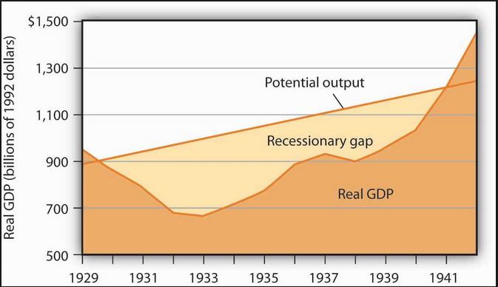

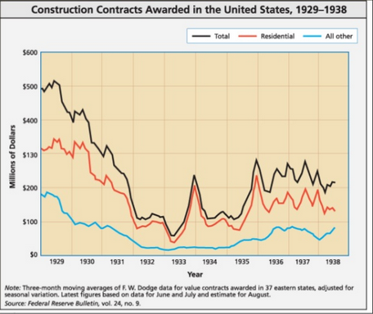
The graph above reveals the seasonal economic variations in the course of the depression as the right measures were being applied.

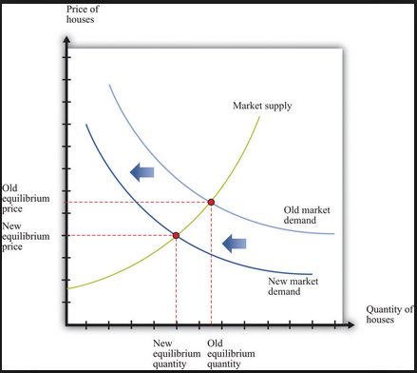
The above graph shows the final market position compared to the initial state of the economy during the crisis.

References
Romer, C. D. (2014). It takes a regime shift: recent developments in Japanese monetary policy through the lens of the Great Depression. NBER Macroeconomics Annual, 28(1), 383-400.
Temin, P. (2016). Great Depression. In Banking Crises (pp. 144-153). Palgrave Macmillan, London.
Borio, C. (2014). Monetary policy and financial stability: what role in prevention and recovery?

